APPLICATION FOR PERMISSION TO FILM IN A PUBLIC PLACE IN COUNTY SLIGO
Contact Details
Name & Address of Production Company
Key Contact Person
Contact Number
Email
Location Manager or Production Manager
Proposed Date, time, location
Please refer to the attached map and tick relevant Municipal District | Ballymote- Tubbercurry ⃝  Sligo Drumcliff ⃝ Sligo Strandhill ⃝
Exact Location within MD with Eircode or GPS Coordinates:
(Sligo County Council cannot approve filming on private lands therefore the applicant must ensure that the location is public land prior to submitting this application)
Proposed date(s) of filming including set-up and derigging
Time(s) of filming | Start:  Finish:
No. of Crew/Cast on location:
Details on Production
Production Budget Estimate: | Less than €1M ⃝  Between €1M - €5M ⃝ Over €5M ⃝
Production Type | Film ⃝ Commercial ⃝  Series ⃝ Documentary ⃝  Other ⃝
Brief Scenes Description
Please give details of any specific
requirements
Will road / footpath / parking bays closure be necessary?

Equipment
What type of equipment will be used for filming?
Total number of vehicles on location
Are you planning on using a Drone for your filming? * PLEASE SEE TERMS & CONDITIONS #3
Insurance Details
Public Liability Insurance | Yes ⃝ No ⃝
Name of Insurance Company/Insurance
Broker
Policy Number
Expiry Date
Employers Liability Insurance | Yes ⃝ No ⃝
Name of Insurance Company/Insurance
Broker
Policy Number
Expiry Date
Is a Risk Assessment/ Health and Safety Plan included | Yes ⃝ No ⃝
*Please ensure Sligo County Council is indemnified on both insurance policies – proof required
*Permission to film will not be granted until all required paperwork is received with completed
application form
Declaration
I, the undersigned confirm that the above information is true and factual
Signature:
Date:

Please complete form and return, along with accompanying documents, to: corporate@sligococo.ie or
Filming Requests, Communications Section, Sligo County Council, County Hall, Riverside, Sligo F91 Y763
Terms and Conditions

Insurance
- Sligo County Council require a copy of the relevant insurance policy, cover should exceed €6.5million in respect of public liability and €13m in respect of employer’s liability. The insurance policy must include an indemnity to Sligo County Council. The applicant is responsible for all and any claims that may arise directly from this filming.

- Risk Assessment

- A detailed Risk Assessment or Health and Safety Plan must be submitted with all applications. Filming activities must not obstruct others from carrying out their business, or; cause a disturbance or safety hazard or impede the mobility of pedestrian’s, goods, or services without adequate prior consultation

Drone Usage
We will require –
- Proof of permission from the Aviation Authority if you are using a drone to film.
- Evidence of drone operations licence and Insurance.

Traffic Management
- In the event that there will be disruption to the normal flow of traffic in the area, the production company is obliged to liaise with the local Gardaí and submit a traffic management plan to Sligo County Council.

Road Closures
- A separate application form must be completed and fees paid in order to request the closure of any public road. A statutory procedure must be carried out to implement a permitted road closure and a minimum of 6 weeks notice must be given. Please contact roadsgeneral@sligococo.ie to request a copy of the application form.

Credits
- Sligo County Council to be acknowledged in the credits.

Filming on Beaches
- Beach & Foreshore Bye-laws must be strictly adhered to.
- The beach must be left free of litter and in the same condition as when entered.
- All damage must be repaired to the satisfaction of Sligo County Council.
- Any Company wishing to film on or in the water must provide their own rescue boat/ water safety personnel.

Fees
- From time-to-time there may be fees involved in the processing of a filming request or Sligo County Council may ask the production company to make a financial contribution to local groups where filming is taking place.

- Protected Sites

- If working in areas designated as a Special Area of Conservation (SAC) or a Special Protected Area (SPA), it is essential to obtain permission from the National Parks and Wildlife Service by contacting the Regional NPWS Office. This applies to both public and private lands. Please contact the Sligo division at (01) 539 3232 or email natureconservation@npws.gov.ie
Designed sites can be viewed at: NPWS Designations Viewer (arcgis.com)

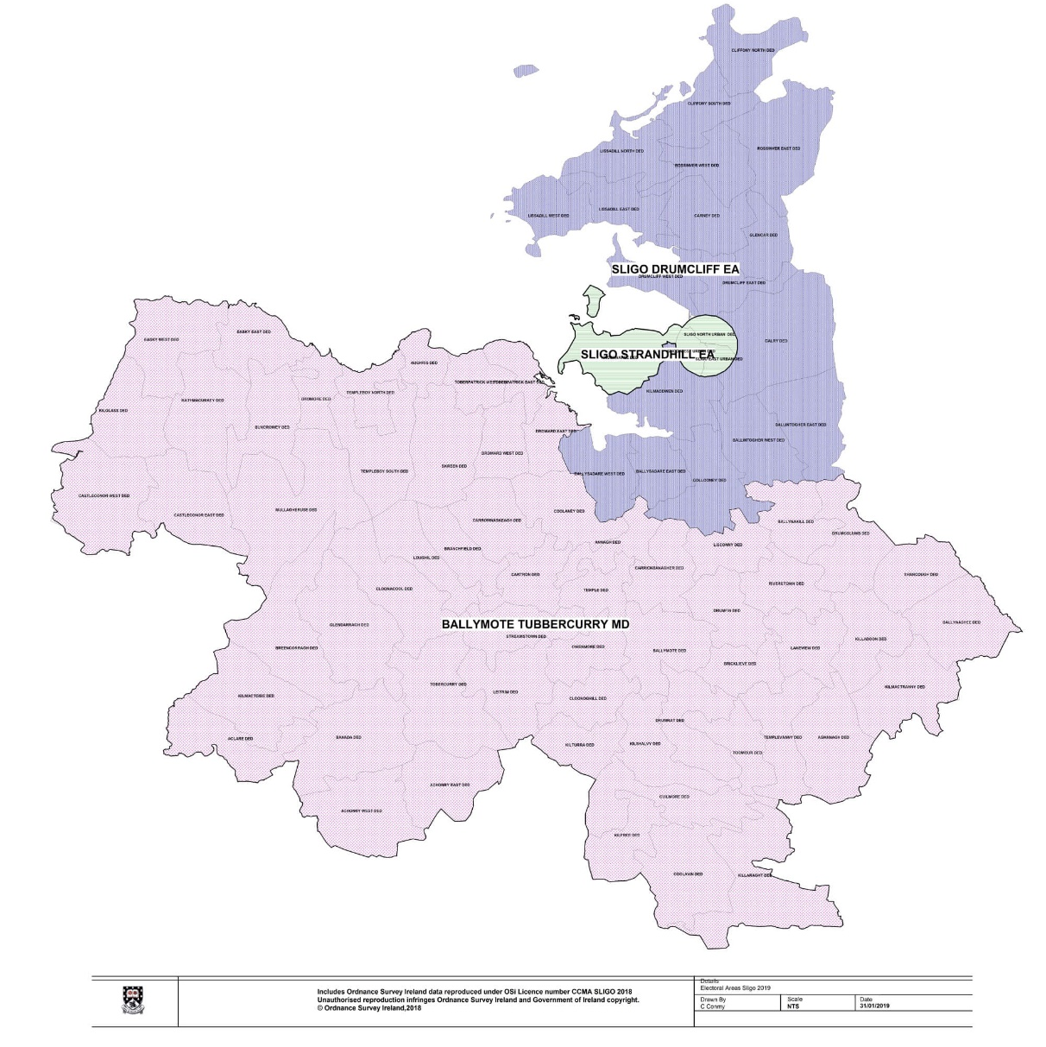
- Litter
- Remember to leave no trace

